**ERD**

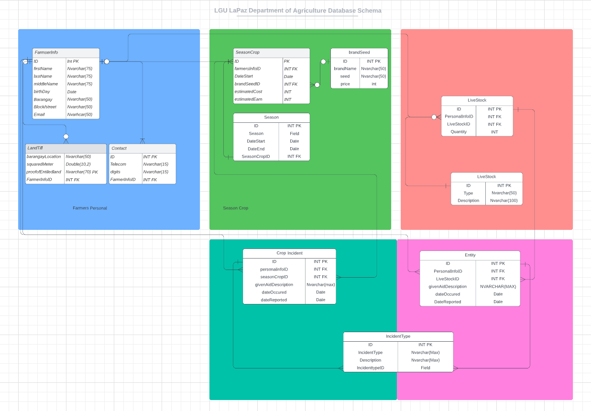

**Source Code**

CREATE TABLE `FarmserInfo` (

`ID` Int PK,

`firstName` Nvarchar(75),

`lastName` Nvarchar(75),

`middleName` Nvarchar(75),

`birthDay` Date,

`Barangay` Nvarchar(50),

`Block/street` Nvarchar(50),

`Email` Nvarhcar(50)

);

CREATE TABLE `LiveStock` (

`INT PK` <type>,

`Nvarchar(50)` <type>,

`Nvarchar(100)` <type>,

KEY `ID` (`INT PK`),

KEY `Type` (`Nvarchar(50)`),

KEY `Description` (`Nvarchar(100)`)

);

CREATE TABLE `LiveStock` (

`INT PK` <type>,

`INT FK` <type>,

`INT FK` <type>,

`INT` <type>,

FOREIGN KEY (`INT FK`) REFERENCES `FarmserInfo`(`ID`),

FOREIGN KEY (`INT FK`) REFERENCES `LiveStock`(`INT PK`),

KEY `ID` (`INT PK`),

KEY `PersonalInfoID` (`INT FK`),

KEY `LiveStockID` (`INT FK`),

KEY `Quantity` (`INT`)

);

CREATE TABLE `brandSeed` (

`ID` INT PK,

`brandName` Nvarchar(50),

`seed` Nvarchar(50),

`price` int

);

CREATE TABLE `SeasonCrop` (

`ID` PK,

`farmersInfoID` INT FK,

`DateStart` Date,

`brandSeedID` INT FK,

`estimatedCost` INT,

`estimatedEarn` INT,

FOREIGN KEY (`ID`) REFERENCES `FarmserInfo`(`ID`),

FOREIGN KEY (`brandSeedID`) REFERENCES `brandSeed`(`ID`)

);

CREATE TABLE `Entity` (

`INT PK` <type>,

`INT FK` <type>,

`INT FK` <type>,

`NVARCHAR(MAX)` <type>,

`Date` <type>,

`Date` <type>,

FOREIGN KEY (`INT FK`) REFERENCES `LiveStock`(`INT PK`),

FOREIGN KEY (`INT FK`) REFERENCES `FarmserInfo`(`ID`),

KEY `ID` (`INT PK`),

KEY `PersonalInfoID` (`INT FK`),

KEY `LiveStockID` (`INT FK`),

KEY `givenAidDescription` (`NVARCHAR(MAX)`),

KEY `dateOccured` (`Date`),

KEY `DateReported` (`Date`)

);

CREATE TABLE `Crop Incident` (

`INT PK` <type>,

`INT FK` <type>,

`INT FK` <type>,

`Nvarchar(max)` <type>,

`Date` <type>,

`Date` <type>,

FOREIGN KEY (`INT FK`) REFERENCES `FarmserInfo`(`ID`),

FOREIGN KEY (`INT FK`) REFERENCES `SeasonCrop`(`ID`),

KEY `ID` (`INT PK`),

KEY `personalinfoID` (`INT FK`),

KEY `seasonCropID` (`INT FK`),

KEY `givenAidDescription` (`Nvarchar(max)`),

KEY `dateOccured` (`Date`),

KEY `dateReported` (`Date`)

);

CREATE TABLE `IncidentType` (

`INT PK` <type>,

`Nvarchar(Max)` <type>,

`Nvarchar(Max)` <type>,

`Field` <type>,

FOREIGN KEY (`Field`) REFERENCES `Entity`(`INT PK`),

FOREIGN KEY (`Field`) REFERENCES `Crop Incident`(`INT PK`),

KEY `ID` (`INT PK`),

KEY `IncidentType` (`Nvarchar(Max)`),

KEY `Description` (`Nvarchar(Max)`),

KEY `IncidenttypeID` (`Field`)

);

CREATE TABLE `LandTill` (

`barangayLocation` Nvarchar(50),

`squaredMeter` Double(10,2),

`proofofEntiledland` Nvarchar(70) PK,

`FarmerInfoID` INT FK

);

CREATE TABLE `Contact` (

`ID` INT PK,

`Telecom` Nvarchar(15),

`digits` Nvarchar(15),

`FarmerInfoID` INT FK

);

CREATE TABLE `Season` (

`INT PK` <type>,

`Field` <type>,

`Date` <type>,

`Date` <type>,

`INT FK` <type>,

KEY `ID` (`INT PK`),

KEY `Season` (`Field`),

KEY `DateStart` (`Date`),

KEY `DateEnd` (`Date`),

KEY `SeasonCropID` (`INT FK`)

);

Data Integration Data Flow

